INSTRUCTIONS TO RESET YOUR PASSWORD

On any page of our website, look for the word “LOGIN” at the top right.

When you click LOGIN, the screen below will appear. If you forgot your password click the Reset Password Link.

Next, the screen below will appear. Simply type your user name (which should be your email address, or something special you created). Next click Send Reset Link.

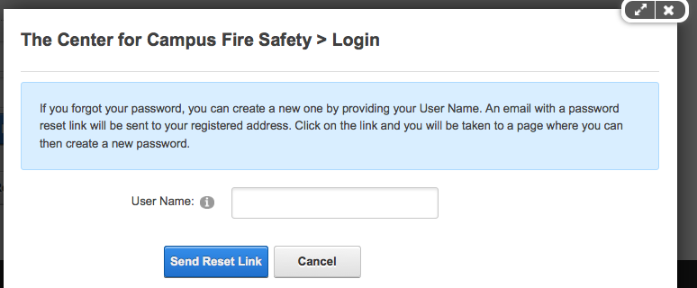

Our system will email you with the opportunity to reset your password. Please be on the lookout for this as you will only have 12 hours to reset your password. After that, for security reasons, you will not be able to reset your password. If that happens – simply go through the process once again.

Question or Problems? SupportTeam@campusfiresafety.org

Note: For security, the support team is not able to see your password.

